St Michael and all Angels
Cottingley
stmichaelsvicar@gmail.com
stmichaelscottingley@gmail.com
Revd. Malcolm Hendry 01274560761

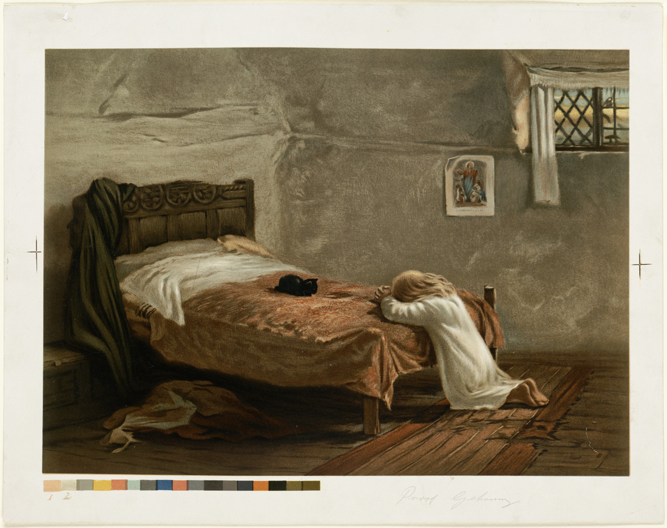

St Michael and all Angels Church

Cottingley
“Church without walls”

7pm Thursday Evening

Service of the Word

We say together the words printed in bold.
The light and peace of Jesus Christ be with you
All and also with you.
The glory of the Lord has risen upon us.
All Let us rejoice and sing God’s praise for ever.

Opening Prayer
Faithful one, whose word is life: come with saving power to free our praise, inspire our
prayer and shape our lives for the kingdom of your Son, Jesus Christ our Lord.
All Amen.
Glory to the Father and to the Son and to the Holy Spirit.
All as it was in the beginning is now and shall be for ever. Amen.

The Word

At the end of each reading this response may be used
This is the word of the Lord.
All Thanks be to God.

Confession and Forgiveness
Christ the light of the world has come to dispel the darkness of our hearts. In his light let
us examine ourselves and confess our sins.
Silence may be kept.
Let us admit to God the sin which always confronts us.
All Lord God, we have sinned against you; we have done evil in your sight. We are
sorry and repent. Have mercy on us according to your love. Wash away our
wrongdoing and cleanse us from our sin. Renew a right spirit within us and restore us
to the joy of your salvation, through Jesus Christ our Lord. Amen.
The minister declares God’s forgiveness.

Praise
Blessed are you, Lord our God, King of the universe.
All To you be glory and praise for ever.

From the rising of the sun to its setting your name is proclaimed in all the world.
All To you be glory and praise for ever.

When the time had fully come you sent the Son of Righteousness.
All In him the fullness of your glory dwells. To you be glory and praise for ever.

Prayers of Thanks and Intercession
This, or some other form, may be used:
We pray to the Lord: in faith we pray.
All We pray to you our God.

That the rest of this day may be holy, peaceful, and full of your presence: in faith we pray.
All We pray to you our God.

That the work we have done and the people we have met today may bring us closer to you; in faith we pray.
All We pray to you our God.

That we may hear and respond to your call to peace and justice; in faith we pray.
All We pray to you our God.

That you will sustain the faith and hope of those who are lonely, oppressed and anxious in faith we pray.
All We pray to you our God.

That you will strengthen us in your service, and fill our hearts with longing for your kingdom; in faith we pray.
All We pray to you our God. God of mercy,
All you know us and love us and hear our prayer: keep us in the eternal fellowship
of Jesus Christ our Saviour. Amen.

The Lord’s Prayer
All Our Father in heaven, hallowed be your name, your kingdom come, your will be
done, on earth as in heaven. Give us today our daily bread. Forgive us our sins as we
forgive those who sin against us. Lead us not into temptation but deliver us from evil.
For the kingdom, the power, and the glory are yours now and for ever. Amen.

Conclusion

Final Prayer
All In darkness and in light, in trouble and in joy, help us, heavenly Father, to trust
your love, to serve your purpose, and to praise your name; through Jesus Christ our
Lord. Amen.

Sending Out
A blessing, the Grace or these responses may be used
Jesus Christ is the light of the world:
All a light no darkness can quench.
Stay with us, Lord, for it is evening:
All and the day is almost over.
The darkness is not dark to you:
All the night is as bright as the day.
Let your light scatter the darkness:
All and fill your church with your glory. Amen.

A service from New Patterns for Worship. Compilation copyright © The Archbishops’ Council 2002. You can find all our services on
Facebook https://www.facebook.com/stmichaelscottingley
Service sheets can be found on https://www.stmichaelscottingley.net/church-without-walls

