St Michael and all Angels Church
Cottingley

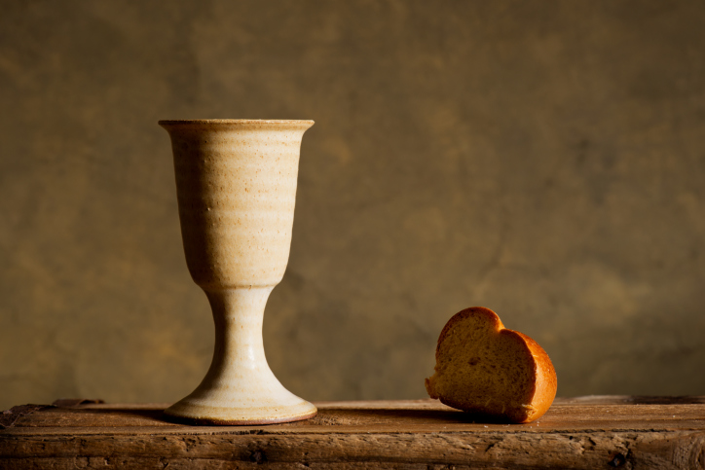
Maundy Thursday Service
With
Holy Communion

Leader In the name of the Father, and of the Son, and of the Holy Spirit,
All Amen.

Leader Jesus told his disciples, ‘If any want to become my followers, let them deny themselves and take up their cross and follow me. For those who want to save their life will lose it, and those who lose their life for my sake will find it.’ Matthew 16.24, 25
Once we were far off, but now in union with Christ Jesus we have been brought near through the shedding of Christ’s blood, for he is our peace.
Ephesians 2.13, 14
Let us pray.
A brief moment of silence follows.
Leader Almighty and everlasting God, who in your tender love towards the human race sent your Son our Saviour Jesus Christ to take upon him our flesh and to suffer death upon the cross: grant that we may follow the example of his patience and humility, and also be made partakers of his resurrection; through Jesus Christ your Son our Lord, who is alive and reigns with you, in the unity of the Holy Spirit, one God, now and for ever.
All Amen.
All Holy God, holy and strong, holy and immortal, have mercy upon us.
Jesus meets the women of Jerusalem
Leader We adore you, O Christ, and we bless you,
All because by your holy cross you have redeemed the world.
Reading A great number of the people followed him, and among them were women who were beating their breasts and wailing for him. But Jesus turned to them and said, ‘Daughters of Jerusalem, do not weep for me, but weep for yourselves and for your children. For the days are surely coming when they will say, “Blessed are the barren, and the wombs that never bore, and the breasts that never nursed.” Then they will begin to say to the mountains, “Fall on us”; and to the hills, “Cover us.” For if they do this when the wood is green, what will happen when it is dry?’
Reflection
‘Weep for yourselves’
He always had an affinity with tears. He noticed them. Even the hidden ones that drop inside the soul and keep falling even when your face is smiling, and no one notices the grief behind the confident façade.
He always asked why: why are you weeping; what is the story of your tears? He knew that we would never find an answer to our sorrow that was second hand,

or off the shelf. It could never be someone else’s answer, no matter how compelling. Until we found the answer in ourselves, until we understood our own grief, until we were able to strip back the layers of pretence and see afresh the cause of our disquiet and our pain, we would always be alone in our sorrow. It would always be an emptying out of grief and never a filling in of grace.
But if we saw, just for a moment, the heart of our dismay, our terrible separation from love, then we would also see the means of grace, see – and now I give it to you second hand, for I have not yet seen it for myself, only glimpsed its terrifying beauty – the face of God in this about-to-be-crucified man.
So when the women who followed in the crowd wept and tore their clothing, he asked them not to weep for him – but for themselves.
Prayer Lord Jesus, the women of Jerusalem wept for you: move us to tears at the plight of the broken in our world. You embraced the pain of Jerusalem, the ‘city of peace’: bless Jerusalem this day and lead it to the path of profound peace. To you, Jesus, the King of peace who wept for the city of peace, be honour and glory with the Father and the Holy Spirit, now and for ever.
All Amen.
All Holy God, holy and strong, holy and immortal, have mercy upon us.
Leader Let us pray for the coming of God’s kingdom in the words our Saviour taught us.
The Lord’s Prayer is said.
Our Father, who art in heaven, hallowed be thy name; thy kingdom come; thy will be done; on earth as it is in heaven. Give us this day our daily bread. And forgive us our trespasses, as we forgive those who trespass against us. And lead us not into temptation; but deliver us from evil. For thine is the kingdom, the power and the glory, for ever and ever. Amen.
Eucharistic prayer
Leader The Lord is here.
All His Spirit is with us.
Leader Lift up your hearts.
All We lift them to the Lord.
Leader Let us give thanks to the Lord our God.
All It is right to give thanks and praise.
Leader It is right to praise you, Father, Lord of all creation; in your love you made us for yourself. When we turned away you did not reject us but came to meet us in your Son. You embraced us as your children and welcomed us to sit and eat with you. In Christ you shared our life that we might live in him and he in us.

He opened his arms of love upon the cross and made for all the Perfect sacrifice for sin.
On the night he was betrayed, at supper with his friends he took bread, And gave you thanks; he broke it and gave it to them, saying: Take, eat; this is my body which is given for you; do this in remembrance of me. Father, we do this in remembrance of him: his body is the bread of life.
At the end of supper, taking the cup of wine, he gave you thanks, and said: Drink this, all of you; this is my blood of the new covenant, which is shed for you for the forgiveness of sins; do this in remembrance of me.
Father, we do this in remembrance of him: his blood is shed for all. As we proclaim his death and celebrate his rising in glory, send your Holy Spirit that this bread and this wine may be to us the body and blood of your dear Son.
As we eat and drink these holy gifts make us one in Christ, our risen Lord. With your whole Church throughout the world we offer you this sacrifice of Praise and lift our voice to join the eternal song of heaven:
All Holy, holy, holy Lord, God of power and might, Heaven and earth are full of your glory. Hosanna in the highest.
Leader Every time we eat this bread and drink this cup All we proclaim the Lord’s death until he comes again
Leader Jesus is the Lamb of God who takes away the sin of the world Blessed are those who are called to his supper
All Lord I am not worthy to receive you, but only say the word and I shall be healed
Prayer after communion
All Almighty God, we thank thee for feeding us with the body and blood Of your Son Jesus Christ. Through him we offer thee our souls and bodies to be a living sacrifice. Send us out in the power of thy Spirit to live and work to your praise and glory. Amen.
Leader The Lord be with you
All and also with you.
Leader May God bless us, that in us may be found love and humility, obedience and thanksgiving, discipline, gentleness and peace.
All Amen.

Stephen Cottrell. Walking the Way of the Cross: Prayers and Reflections on the biblical Stations of the Cross. Church House Publishing. Copyright © The Archbishops’ Council 2019. All Images Copyright © 2013 Nicholas Markell | Eyekons

