St Michael and all Angels
Cottingley
stmichaelsvicar@gmail.com
01274560761

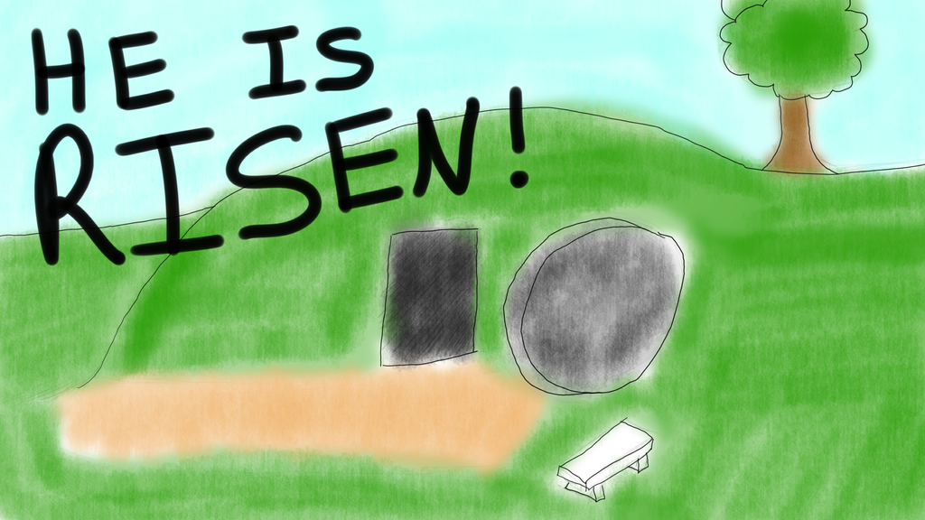
He Is Risen Indeed Alleluia

Opening hymn - come people of the risen king
Come, people of the Risen King,
Who delight to bring Him praise;
Come all and tune your hearts to sing
To the Morning Star of grace.
From the shifting shadows of the earth
We will lift our eyes to Him,
Where steady arms of mercy reach
To gather children in.
Rejoice, Rejoice! Let every tongue rejoice!
One heart, one voice; O Church of Christ, rejoice!
Come, those whose joy is morning sun,
And those weeping through the night;
Come, those who tell of battles won,
And those struggling in the fight.
For His perfect love will never change,
And His mercies never cease,
But follow us through all our days
With the certain hope of peace.
Come, young and old from every land -
Men and women of the faith;
Come, those with full or empty hands -
Find the riches of His grace.
Over all the world, His people sing -
Shore to shore we hear them call
The Truth that cries through every age:
"Our God is all in all"!
Keith & Kristyn Getty & Stuart Townend

Before communion - alleluia alleluia give thanks for the risen lord
Alleluia, Alleluia, give thanks to the risen Lord,
Alleluia, alleluia, give praise to His name.
Jesus is Lord of all the earth.
He is the King of creation.
Alleluia, Alleluia…

Spread the good news o’er all the earth.
Jesus has died and has risen.
Alleluia, Alleluia, …
We have been crucified with Christ.
Now we shall live forever
Alleluia, Alleluia…

God has proclaimed the just reward:
Life for us all, alleluia!
Alleluia, Alleluia, …

Come, let us praise the living God,
Joyfully sing to our Saviour.
Alleluia, Alleluia, …

Final hymn - there is a hope

There is a hope that burns within my heart,
That gives me strength for every passing day;
A glimpse of glory now revealed in meagre part,
Yet drives all doubt away:
I stand in Christ, with sins forgiven;
And Christ in me, the hope of heaven!
My highest calling and my deepest joy,
To make His will my home.

There is a hope that lifts my weary head,
A consolation strong against despair,
That when the world has plunged me in its deepest pit,
I find the Saviour there!
Through present sufferings, future’s fear,
He whispers ‘courage’ in my ear.
For I am safe in everlasting arms,
And they will lead me home.

There is a hope that stands the test of time,
That lifts my eyes beyond the beckoning grave,
To see the matchless beauty of a day divine
When I behold His face!
When sufferings cease and sorrows die,
And every longing satisfied.
Then joy unspeakable will flood my soul,
For I am truly home.
Stuart Townend

