St Michael and all Angels
Cottingley
stmichaelsvicar@gmail.com
01274560761

Evening Prayer
Easter Season

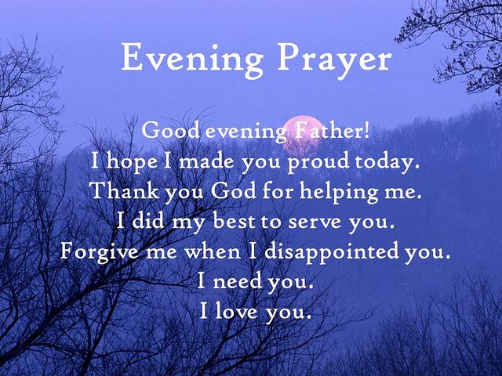

During the lockdown Evening Prayer

will be said at 7pm on Thursday Evening

Find us on Facebook https://www.facebook.com/stmichaelscottingley

Service sheets can be found on https://www.stmichaelscottingley.net/church-without-walls

Preparation
O God make speed to save us.
All O Lord make haste to help us.
In your resurrection, O Christ,
All let heaven and earth rejoice.
Alleluia.
prayer of thanksgiving
Blessed are you, Sovereign Lord, the God and Father of our Lord Jesus Christ, to you be glory and praise for ever. From the deep waters of death you brought your people to new birth by raising your Son to life in triumph. Through him dark death has been Destroyed and radiant life is everywhere restored. As you call us out of darkness into his marvellous
light may our lives reflect his glory and our lips repeat the endless song. Blessed be God, Father, Son and Holy Spirit.
All Blessed be God for ever.

A Song of David
Refrain:
All Splendour and majesty are yours, O God; you are exalted as head # over all.
1 Blessed are you, God of Israel, for ever and ever, ♦ for yours is the greatness, the power, the glory, the splendour and the majesty. 2 Everything in heaven and on earth is yours; ♦ yours is the kingdom, O Lord, and you are exalted as head over all. 3 Riches and honour come from you ♦ and you rule over all. 4 In your hand are power and might; ♦ yours it is to give power and strength to all. 5 And now we give you thanks, our God, ♦ and praise your glorious name. 6 For all things come from you, ♦ and of your own have we given you.
1 Chronicles 29.10b-13,14b
All Glory to the Father and to the Son and to the Holy Spirit; as it was in the beginning is now and shall be for ever. Amen.
All Splendour and majesty are yours, O God; you are exalted as head over all.

This opening prayer may be said
That this evening may be holy, good and peaceful, let us pray with one heart and mind.
Silence is kept.
As our evening prayer rises before you, O God, so may your mercy come down upon us to cleanse our hearts and set us free to sing your praise now and for ever.
All Amen.

The Word of God

The appointed Psalm is said
Each psalm or group of psalms may end with
All Glory to the Father and to the Son and to the Holy Spirit; as it was in the beginning is now and shall be for ever. Amen.
Canticle
A Song of Faith,
Refrain:
All God raised Christ from the dead, the Lamb without spot or stain. Alleluia.
1 Blessed be the God and Father ♦ of our Lord Jesus Christ!
2 By his great mercy we have been born anew to a living hope ♦ through the resurrection of Jesus Christ from the dead, 3 Into an inheritance that is imperishable, undefiled and unfading, ♦ kept in heaven for you, 4 Who are being protected by the power of God through faith, ♦ for a salvation ready to be revealed in the last time.5 You were ransomed from the futile ways of your ancestors ♦ not with perishable things like silver or gold 6 But with the precious blood of Christ ♦ like that of a lamb without spot or stain.7 Through him you have confidence in God, who raised him from the dead and gave him glory, ♦ so that your faith and hope are set on God.
1 Peter 1.3-5,18,19,21
All Glory to the Father and to the Son and to the Holy Spirit; as it was in the beginning is now and shall be for ever. Amen.
All God raised Christ from the dead, the Lamb without spot or stain. Alleluia.

Scripture Reading
Responsory
The Lord is my strength and my song: he has become my salvation.
All The Lord is my strength and my song: he has become my salvation.
I shall not die, but live, and declare the works of the Lord.
All He has become my salvation.
Glory to the Father and to the Son and to the Holy Spirit.
All The Lord is my strength and my song: he has become my salvation.
from Psalm 118

Gospel Canticle Great and Wonderful
Refrain:
All All nations shall come and worship you, O Christ, and share in the feast of your kingdom.
1 Great and wonderful are your deeds, ♦ Lord God the Almighty. 2 Just and true are your ways, ♦ O ruler of the nations. 3 Who shall not revere and praise your name, O Lord? ♦ for you alone are holy.

4 All nations shall come and worship in your presence: ♦ for your just dealings have been revealed.
Revelation 15.3,4
All To the One who sits on the throne and to the Lamb ♦ be blessing and honour and glory and might, for ever and ever. Amen.
All All nations shall come and worship you, O Christ, and share in the feast of your kingdom.

Prayers
Intercessions are offered, for peace, for individuals and their needs. Response
Lord, in your mercy
hear our prayer.
Silence may be kept. The following is said
God of life, who for our redemption gave your only-begotten Son to the
death of the cross, and by his glorious resurrection have delivered us from
the power of our enemy: grant us so to die daily to sin, that we may
evermore live with him in the joy of his risen life; through Jesus Christ
our Lord.
All Amen.
The Lord’s Prayer is said
Rejoicing in God’s new creation, as our Saviour taught us, so we pray
All Our Father in heaven …

The Conclusion
May the risen Christ grant us the joys of eternal life.
All Amen.
Let us bless the Lord. Alleluia, alleluia.
All Thanks be to God. Alleluia, alleluia.

Common worship: services and prayers
for the Church of England, material of which is included
in this service is copyrighted “The Archbishops Council 2000”

