St Michael and all Angels
Cottingley
stmichaelsvicar@gmail.com
Revd. Malcolm Hendry 01274560761

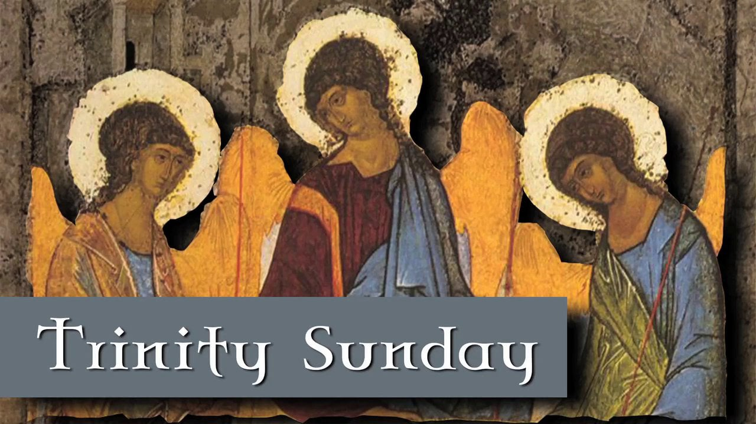

St Michael and all Angels Church Cottingley
“Church without walls”
Sunday Lite Service
With Holy Communion

Welcome Lily Eteson
Hymn. I am a new creation
Confession By Eli and Camilla
[ELI]
A time to say sorry

We know that God is love and that God loves all that he has made.
He loves you and me.
Jesus shows us and tells us that God will never turn anyone away who comes to him.
But our lives are far from perfect.
We know that we are not always the best we can be, nor the best God longs us to be.
But God accepts us as we are, and he asks us to come to Jesus his Son and say sorry.

[CAMILLA]
Now hold out your hand in front of you.

- Make a fist with your hand.
We are sorry for the times we have got angry with other people.

- Point your finger away from you.
We are sorry for the times we have blamed others and seen things wrong in others without recognising how much is also wrong in us.

- Close up your hand and hold it close to your chest.
We are sorry for the times we have kept things selfishly to ourselves and not been prepared to give to those who need our help.

- Close your lips tightly.
We are sorry for the foolish words we have spoken which have hurt other people.

- Close your eyes.
We are sorry that we have deliberately chosen not to see the good things we could have done to help other people.

- Put your hand over one ear.
We are sorry for the times we have not listened to the cries of those who are poor or who suffer injustice.

Now hold out your hand with an open palm upward, as if you are waiting to receive something.
Jesus says, 'If you are tired from carrying heavy burdens, come to me and I will give you rest'.
So, we bring all that we are to Jesus - all our wrongdoings and our failure to love. Thank you, Lord, for your forgiveness.
[picture of Jesus forgiving woman]

Finally trace the shape of a cross with the finger of your other hand across the palm of the hand you are holding out.
[ELI]
Heavenly God,
On this Trinity Sunday forgive our selfishness,
Let us use our time positively to help us to be faithful servants
of You our heavenly King,
Amen
Absolution

May almighty God forgive all who truly repent. May he have mercy upon us, pardon and deliver us from all our sins, confirm and strengthen us in all goodness, and keep us in life eternal through Jesus Christ our Lord

Amen

Bible reading
Sunday Lite – 7 June2020
Matt 28:16-20

A few more weeks after their picnic on the beach, when Jesus broiled fish over an open fire, the time came for Jesus to leave- to go to Heaven to be with God His Father. So, He took one last walk with His friends, up a hill near the Sea of Galilee, where their adventures together had begun. He said to them-
“I’ve got to go now, and there is something I want you to do. Tell my story to the world, baptising them in the Name of the Father, and the Son, and the Holy Spirit. Start in Jerusalem and don’t stop until everybody has the chance to follow me. “And if you ever feel scared or alone, don’t worry. Just talk to me and I’ll be with you. I promise.”

Hymn I have a trinity song to the tune of frere jacques

Talk

John

Hymn Be still and know that I am God

Time to pray Written by June read by Laura
Let us pray, you are God creator, giving us richly you are Christ made flesh to set us free. You are sprit truth and love willing to dwell in us. You are the perfect unity of love. We pray for our church without walls, Malcolm ministry and all those who are reaching out locally to help others. We pray for all church leaders who are working to comfort and support the community and individuals.
Lord in your mercy hear our prayer.
We pray for those in leadership roles in our world that they make the right decisions at the right time to save lives. We pray for ordinary people who find themselves in extraordinary situations. We pray for all those who care for others and put the needs of others before themselves. We pray for the work of charities that they make a real difference and we pray for a fairer world
Lord in your mercy hear our prayer
We pray for ourselves to be full of compassion and help us to worship you one God in three persons. By proclaiming and living out our faith
Lord in your mercy hear our prayer
We pray for those who are sick lonely or sad that they may be aware of your comforting presences and know that in your hands they are loved
Lord in your mercy hear our prayer
Lord we ask for you to lead us into the coming weeks and helps us believe you are clos by us . we know that no darkness can quench Jesus light of the world
Please accept these prays in the name of the father Son and holy spirt one God true and living for ever and ever amen

Lord’s Prayer Stuart /Helen Eteson
Our father in heaven hallowed be your name. Your kingdom comes. Your will be done on earth as in heaven. Give us today our daily bread. Forgive us our sins as we forgive those who sin against us. Lead us not into temptation but deliver us from evil. For the kingdom, the power and the glory are yours, now and forever. Amen.
Hymn Father we adore you

Communion
The story of the Last Supper
Among friends gathered round a table Jesus took bread, and having blessed it he broke the bread and gave it to his disciples saying “This is my body which is given for you”
In the same way he took wine. And having given thanks for it he poured it out and gave the cup to his disciples saying “This cup is the new relationship with God, sealed with my blood. Take this and share it.”

Blessing of the Bread and Wine
Lord Jesus Christ present with us now As we do in this place what you did in an upstairs room Breathe your Spirit upon us, and upon this bread and wine. That they may be heaven’s food and drink for us Renewing, sustaining, and making us whole. And that we may be your body on earth Loving and caring in the world.

Breaking and Sharing of the Bread and Wine
“Look, the bread of heaven is broken for the life of the world. The gifts of God, for the people of God”

Prayer after Communion
God of truth, we have seen with our eyes and touched with our hands the bread of life. Strengthen our faith. That we may grow in love for you. And for each other.
Amen.

Blessing
On this Trinity Sunday may you feel God’s Love, God’s healing power and his presence in your life. May you feel the Father the Son and the Holy Spirit surround you and lift you. may you know that the three in one will always be there in your life. And the blessing of God Almighty Father Son and Holy Spirit be with you and remain with you always.
Hymn Jesus put this song into my heart

©the archbishops' council of the church of England and the Iona community

