St Michael and all Angels
Cottingley
stmichaelsvicar@gmail.com
01274560761

Morning Prayer

Easters Season

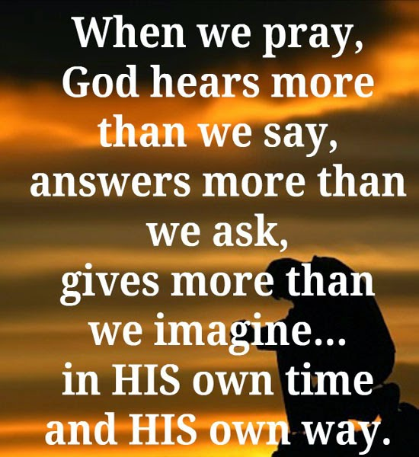

During the lockdown Morning Prayer will be said at 7am on Wednesday Mornings

Find us on Facebook https://www.facebook.com/stmichaelscottingley

Service sheets can be found on https://www.stmichaelscottingley.net/church-without-walls

Preparation
O Lord, open our lips
All and our mouth shall proclaim your praise.
In your resurrection, O Christ,
All let heaven and earth rejoice. Alleluia.
prayer of thanksgiving
Blessed are you, Lord God of our salvation, to you be praise and glory for ever. As once you ransomed your people from Egypt and led them to freedom in the promised land, so now you have delivered us from the dominion of darkness and brought us into the kingdom of your risen Son. May we, the first fruits of your new creation, rejoice in this new day you have made, and praise you for your mighty acts. Blessed be God, Father, Son and Holy Spirit.
All Blessed be God for ever.

Easter Anthems are read
1 Christ our passover has been sacrificed for us: ♦ so let us celebrate the feast, 2 not with the old leaven of corruption and wickedness: ♦ but with the unleavened bread of sincerity and truth. 1 Corinthians 5.7b, 8
3 Christ once raised from the dead dies no more: ♦ death has no more dominion over him. 4 In dying he died to sin once for all: ♦ in living he lives to God. 5 See yourselves therefore as dead to sin: ♦ and alive to God in Jesus Christ our Lord. Romans 6.9–11
6 Christ has been raised from the dead: ♦ the first fruits of those who sleep. 7 For as by man came death: ♦ by man has come also the resurrection of the dead; 8 for as in Adam all die: ♦ even so in Christ shall all be made alive.
1 Corinthians 15.20–22

All Glory to the Father and to the Son and to the Holy Spirit; as it was in the beginning is now and shall be for ever. Amen.

This opening prayer may be said
The night has passed, and the day lies open before us; let us pray with one heart and mind.
Silence is kept.
As we rejoice in the gift of this new day, so may the light of your presence, O God, set our hearts on fire with love for you; now and for ever.
All Amen.

The Word of God

Psalmody The appointed Psalm is said. Each psalm or group of psalms may end with
All Glory to the Father and to the Son and to the Holy Spirit; as it was in the beginning is now and shall be for ever. Amen.

Canticle
The Song of Moses and Miriam,
1 I will sing to the Lord, who has triumphed gloriously, ♦ the horse and his rider he has thrown into the sea. 2 The Lord is my strength and my song ♦ and has become my salvation. 3 This is my God whom I will praise, ♦ the God of my forebears whom I will exalt. 4 The Lord is a warrior, ♦ the Lord is his name. 5 Your right hand, O Lord, is glorious in power: ♦ your right hand, O Lord, shatters the enemy. 6 At the blast of your nostrils, the sea covered them; ♦ they sank as lead in the mighty waters. 7 In your unfailing love, O Lord, ♦ you lead the people whom you have redeemed. 8 And by your invincible strength ♦ you
will guide them to your holy dwelling. 9 You will bring them in and plant them, O Lord, ♦ in the sanctuary which your hands have established.
Exodus 15.1b–3,6,10,13,17
Refrain:
All In your unfailing love, O Lord, you lead the people whom you have redeemed. Alleluia.

Scripture Reading
responsory in this or another form, may follow
Death is swallowed up in victory.
All Where, O death, is your sting?
Christ is risen from the dead, the first fruits of those who have fallen asleep.
All Death is swallowed up in victory.
The trumpet will sound and the dead shall be raised.
All Where, O death, is your sting?
We shall not all sleep, but we shall be changed.
All Death is swallowed up in victory. Where, O death, is your sting?
from 1 Corinthians 15

Gospel Canticle
The Song of Christ’s
All At the name of Jesus every knee shall bow.
1 Christ Jesus was in the form of God, ♦ but he did not cling to equality with God. 2 He emptied himself, taking the form of a servant, ♦ and was born in our human likeness. 3 Being found in human form he humbled himself, ♦ and became obedient unto death, even death on a cross. 4 Therefore God has highly exalted him, ♦ and bestowed on him the name above every name, 5 That at the name of Jesus every knee should bow, ♦ in heaven and on earth and under the earth; 6 And every tongue confess that Jesus Christ is Lord, ♦ to the glory of God the Father.
Philippians 2.5-11
All Glory to the Father and to the Son and to the Holy Spirit; as it was in the beginning is now and shall be for ever. Amen.
All The Lord is risen from the tomb who for our sakes hung upon the tree. Alleluia.

Prayers
Intercessions: for the day and its tasks, for the world and its needs, for the Church and her life
These responses may be used
Lord, in your mercy
hear our prayer.
Silence may be kept.
The Collect the following is said
God of life, who for our redemption gave your only-begotten Son to the death of the cross, and by his glorious resurrection have delivered us from the power of our enemy: grant us so to die daily to sin, that we may evermore live with him in the joy of his risen life; through Jesus Christ our Lord.
All Amen.

The Lord’s Prayer is said
Rejoicing in God’s new creation, as our Saviour taught us, so we pray
All Our Father in heaven …

The Blessing

The Conclusion
May the risen Christ grant us the joys of eternal life.
All Amen.
Let us bless the Lord. Alleluia, alleluia.
All Thanks be to God. Alleluia, alleluia.

Common worship: services and prayers
for the Church of England, material of which is included
in this service is copyrighted “The Archbishops Council 2000”

