St Michael and all Angels
Cottingley
stmichaelsvicar@gmail.com
stmichaelscottingley@gmail.com
Revd. Malcolm Hendry 01274560761

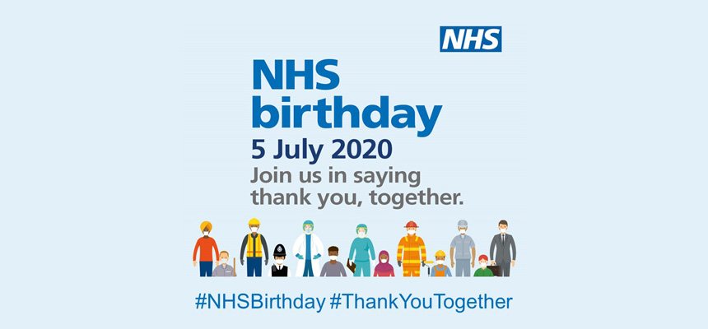

3 John 1:2 Beloved, I pray that all may go well with you and that you may be in good health, as it goes well with your soul
Please remember you can find all our services on

Facebook https://www.facebook.com/stmichaelscottingley

Service sheets and Youth Church activities can be found on https://www.stmichaelscottingley.net/church-without-walls

Hi Everyone

With this being the birthday of the NHS I thought the verse above was appropriate. I do pray for each of you daily that you stay well in both mind body and spirit and that you are following guidelines even though we often don’t agree or understand. Today we are saying thank you to our amazing NHS but let us not lose sight of all those we need to say thanks to. All the key workers who have put themselves and their families at risk so we could stay safe.

I have no doubt most of you will have heard that churches can open again from the 4th of July. Please keep in mind the wise words of Bishop Nick “can does not mean must” Many times the government make statements but have not had discussions with the church first. They also make statements without substance and clear guidelines. Therefore, we have to wait until we get guidelines from the Bishops before we can move forward. In the main the information we now have telling us how and what we need to do to open safely is now complete.

The biggest question at the moment is not how do we open but when. I have today sent this to the PCC for them to look with two question, should we open and when. Once we have decided that then we can start to look at how we can do that.

I am not going to rush to re-open the church, lives are more important than getting back into the building

I know many of you would love to get back and so would I. Our aim and objectives when considering re-opening are how we can keep everyone safe and healthy and still worship God.

Worshiping God can be done anywhere not just in the building but I know many of you like me are missing church family and this will be taken into account in our thinking.

Church will not be the same as we have known it in the past. It could well be a long time before it is. There will be several restrictions on our services when we do re-open. No singing, communion in kind only(just the bread), 2mtr distance between people not of the same household, no sharing the peace, no tea and coffee after the service, no stopping to chat with friends, a register to be taken with names and addresses for track and trace records. These and many more restrictions are what we need to think through before we re-open.

I appreciate the pcc have a responsibility for the welfare of the church and congregation but this goes beyond that into our community. This is much bigger than an individual its about family and community.

I am asking you to please be patient at this time. I know you have waited a long time and I know some of you are still on lockdown . I truly believe we need to think this through logically and come up with a safe way of re-opening church and only when we are sure then we can re-open safely. In the meantime I would love to hear what each and everyone of you think. If you would like to email me on stmichaelsvicar@gmail.com or ring me on 01274560761.

You are all part of the church family, we value each one of you and your opinion matters so please do contact me

For the Sunday Gang home church this week I thought we would do something different . as its NHS birthday I have put a couple of links below just for fun with things the NHS recommended for kids to be doing during lockdown. Below that a few game ideas if you replace mum or dad for teacher or maybe have mum and dad against the kids in some of them. Just have fun together . also if you go to the link https://www.stmichaelscottingley.net/church-without-walls there will be lots of other fun things to do together and for the kids.

God Bless

Malcolm

https://www.nhs.uk/change4life/activities/indoor-activities

https://www.justonenorfolk.nhs.uk/covid-19-coronavirus-faqs/covid-19-activities-for-the-family

FAITH RELAYS: Divide children into teams. The teacher will ask a series of questions and each question will be one relay. (1) Ask the children - Do you have FAITH that your team can roll this potato to the finish line? (Run the relay). (2) Ask the children - Do you have FAITH that your team can pop all your balloons before the other team? Give each team player one balloon to pop and run the relay). (3) Ask children - Do you have FAITH that you can hop on one foot to the finish line and back? Continue to give children relays to run to show their FAITH in what they can do, as time allows.
SONG BOARD: Print off the words to the song MY GOD IS SO BIG and give each child a copy. Have the children glue the sheets to a thin board or a plaque and then decoupage the top by painting over it with glue. Let the song board dry and attach a hook to the back for children to hang up in their homes.
KEYS OF FAITH: Children can cut out tracings of keys in bright colours. Encourage the children to decorate their keys with a border and glitter, and words of FAITH from our story, or ideas that the children have about FAITH and believing in God.
POSTER KEY OF FAITH: The teacher can make a large poster with the word FAITH written on a large tracing of a key. Let the children take turns coming to the KEY OF FAITH and write words that they have learned from today's lesson about FAITH and unlocking God's POWER — words such as mighty, power, obstacles won, amazing power, healed, God is amazing, etc.
FAITH BANNERS: Let the children trace the outline of each other on long white rolls of paper. Then they will colour themselves. Give each child a piece of construction paper for them to make a banner that says F-A-I-T-H and glue it on their traced person. Put all the children's body tracings on the classroom wall! Each week for a month, if desired, the teacher will let the children write something they've learned about Faith or what they've had the FAITH to do during the past week. Make sure they have brightly coloured markers for these ideas and children can share with the class what they have written and why.
SING A SONG: MY GOD IS SO BIG; ONLY BELIEVE
SHARE A SNACK: FAITH CUPCAKES - Make cupcakes with something special in the middle of the treat and ask children if they have faith that THEIR cupcake has some special treat in the middle. (A piece of candy, fruit, a mini Oreo cookie, etc.) ENJOY the filled cupcakes together after thanking God for giving us FAITH to believe and for HIS mighty POWER!

