St Michael and all Angels
Cottingley
stmichaelsvicar@gmail.com
stmichaelscottingley@gmail.com
Revd. Malcolm Hendry 01274560761

You can find all our services on

Facebook https://www.facebook.com/stmichaelscottingley

Service sheets can be found on https://www.stmichaelscottingley.net/church-without-walls

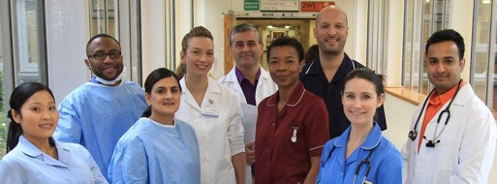

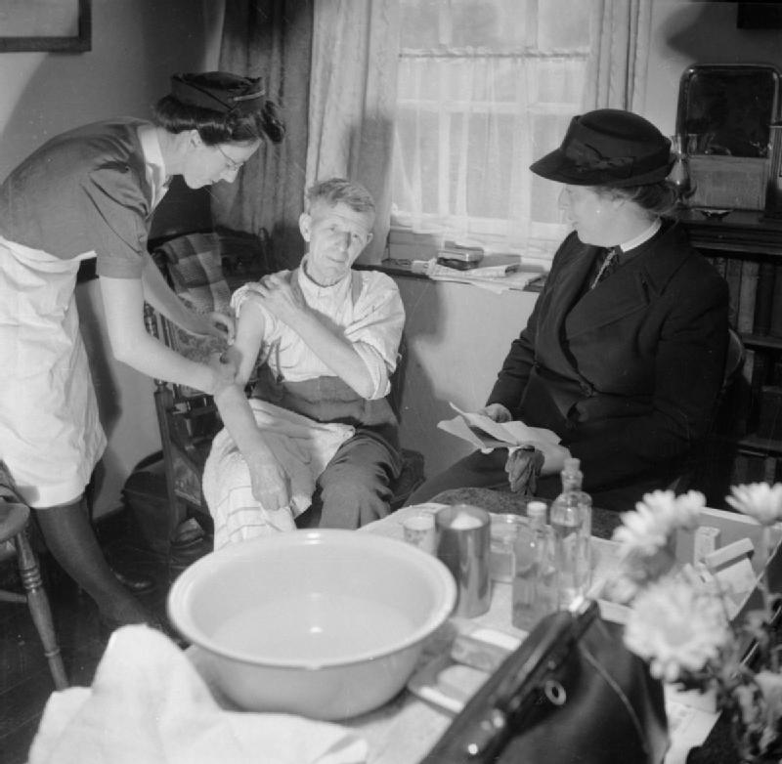

St Michael and all Angels Church Cottingley
“Church without walls”
Sunday Lite Service
Welcome John
Hymn
Bible reading June and John

Hymn
Talk : Camillia interviewing Pam Sharp and Jo Raynard
Hymn

Time to pray Judy and Chris
Lord’s Prayer
Our father in heaven hallowed be your name. Your kingdom comes. Your will be done on earth as in heaven. Give us today our daily bread. Forgive us our sins as we forgive those who sin against us. Lead us not into temptation but deliver us from evil. For the kingdom, the power and the glory are yours, now and forever. Amen.
Hymn

Blessing
Hymn

Video clip to fit in.

©the archbishops' council of the church of England and the Iona community

